Grandpa’s full name was Gregory Franklin Holloway. His business card said he was an “electrical engineer,” but we all thought of him as an inventor.
His first inventions were all for the mining industry in Brimley Forge, which was still going strong when he was young. The mines were dangerous places: dark, cramped, and sometimes filled with invisible gases that could poison you or blow up if someone struck a match in the wrong spot.
Grandpa figured there had to be a better way to keep people safe. So he built a gadget that could smell danger. Not like a person smells, with a nose, but using chemistry and electricity.
Here’s how it worked: He used a special kind of metal oxide sensor. When it came into contact with gases like methane or carbon monoxide, the way it conducted electricity changed. Basically, when the air turned bad, the sensor sent a tiny electrical signal through the rest of the circuit. That signal turned on a red warning light and made the device beep, and it was a loud, ugly beep, like a frog with a fire alarm in its throat.
Grandpa built the first detector from busted radios, flashlight batteries, and a circuit board he etched by hand. He did it all in his garage. He called it the NYX, which stood for “Noxious Yield Exposure,” and stamped a small image of a raven on the front of every one of them.
“Nyx is the Greek goddess of the night,” Grandpa explained to me once. “And my device kept miners from falling into a permanent sleep.”
“But why the raven?” I asked.
“Because ravens are cool,” Grandpa said.
For a short time in the 1970s, Grandpa and a small team of helpers worked full time to mass produce NYX devices for miners all over America. Grandpa started designing and manufacturing other devices for the mining industry, and soon a new business was born.
(Sketch: Grandpa’s original NYX device label – a raven stamped over circuit lines)
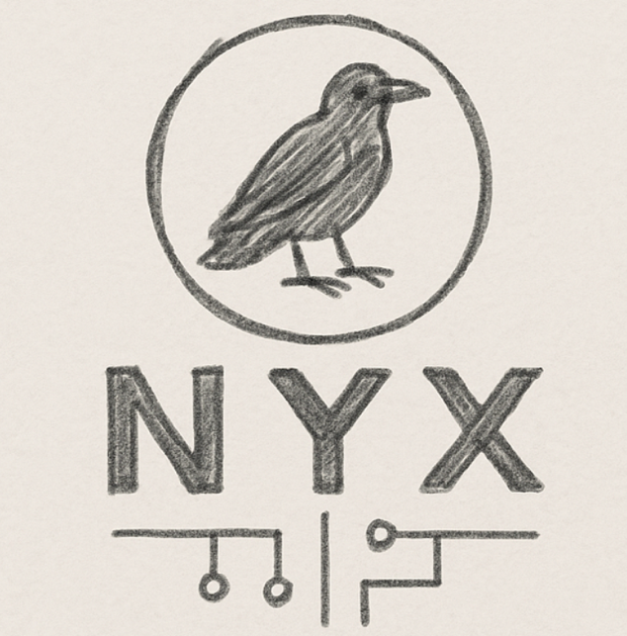
Grandpa’s NYX business had its heyday in the late 1970s and early 80s. At its peak, Grandpa had 14 employees and took over the old Barnaby’s building, transforming a former department store into a humming little factory.
But as the mining industry faded from Brimley Forge, NYX sales slowly shrank, and in 1994, Grandpa officially shut down the company. The old factory became Grandpa’s personal workshop, the place we would eventually start calling The Fortress.
Over the next 20 years, Grandpa eased into retirement. NYX had made him a small fortune, which allowed him to turn his workshop into a full-on mad scientist’s den (in the best possible way). By the time I was born, he still took the occasional engineering job around town, but mostly he just followed the whims of his imagination, morning to night.
Some of my earliest memories take place in his workshop. In those early memories, I remember the workshop kind of felt like a spaceship, and I would sometimes pretend I was on a spaceship when I was there, a spaceship filled with workbenches, wires, tool chests, blinking lights, and shelves stacked to the ceiling with mysterious boxes and motors and jars of tiny parts.
I remember that, when Grandpa taught me about science and engineering when I was little, it felt like he was doing actual magic.
I remember one day when Grandpa picked me up from kindergarten and took me to his lab while we waited for my parents to finish work. He said, “You wanna see something cool?”
I loved that. So many of my great memories of Grandpa started with him saying You wanna see something cool?
I said yes, of course, and then Grandpa took a copper wire, wrapped it around a wrench, and hooked the ends up to a battery.
Then he picked up a bunch of paper clips with the wrench, like it had turned into a magnet. I remember gasping, totally amazed.
“See?” he said. “An electric current creates a magnetic field.”
Then he unhooked the battery, and the magnetism vanished. The paper clips fell off. I thought it was the coolest thing I’d ever seen.
Moments like that dominate my memories of childhood. And though things got weird at the end (very weird – more on that later), nearly all the lessons Grandpa taught me were just simple explorations of math, science, and engineering. Grandpa taught me about negative numbers and exponents long before we learned that stuff in school. He taught me about the 6 simple types of machines. He taught me about gears and gear ratios. He started teaching me about electricity and circuits right before he died.
But he never taught me much about computers, even though he was a skilled programmer, and the Fortress was filled with the carcasses of old PCs. I always figured we’d get to it someday.
Apparently, he figured that too. (sketch in margins of puzzle box with lid open)
I sat alone on my bed, having just opened the puzzle box Grandpa had sent me. I lifted the lid, looked inside.
The first thing I pulled out was a note in Grandpa’s handwriting, written on a tiny scrap of paper.
It said, “Sorry we didn’t get to this, Cap. Now you’ll have to learn it on your own.”
Underneath the note was what looked like a piece of hardware from inside a computer.
I lifted it out of the box.
It was a small circuit board, about the size of a playing card. It had a black microchip in the center, some silver pins around the edges, and rows of little holes for wires.
There was a silver port on one end—it looked like you could attach a USB cable to it.
“What is this, Grandpa?” I whispered.

You can create a simulated version of Grandpa’s Mobile Gas Sensor in the bonus projects section of gavinholloway.com

